Tournament Stat vs User Stat vs League Stat

Tournament Stat Page: consist of 3 charts
- Global Top Ten Players in terms of Total points. If we are showing in tabular format, we need to display column(Rank, Name, Team, Points)
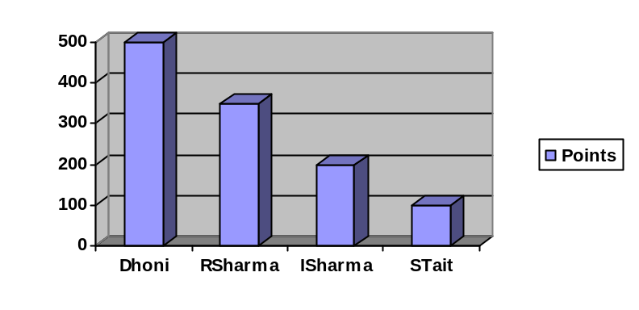
OR
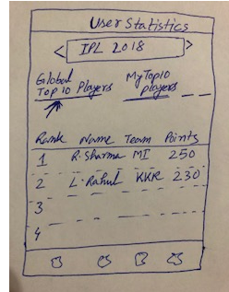

API: http://ec2-52-207-99-56.compute-1.amazonaws.com/FantasyCricketRest/api/fantasycricket/user-stats-global-top-players

- Global Top Ten Teams in terms of Total Points. If we are showing in tabular format we need to show column as (Rank, Team, Owner, Points)
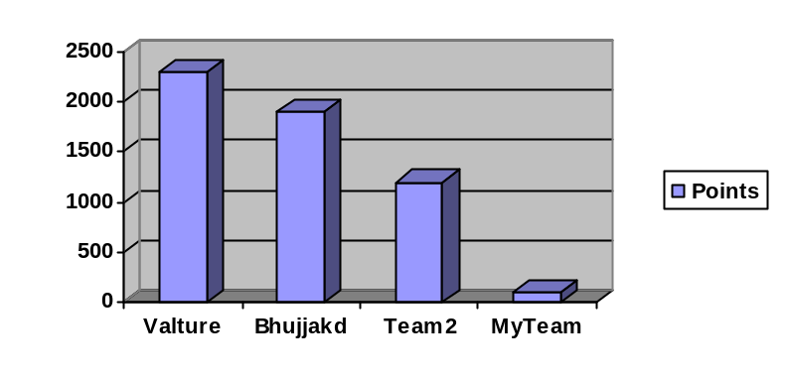
OR
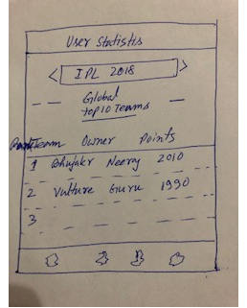
API: http://ec2-52-207-99-56.compute-1.amazonaws.com/FantasyCricketRest/api/fantasycricket/user-stats-global-top-teams

- Global Top Ten Leagues in terms of average points
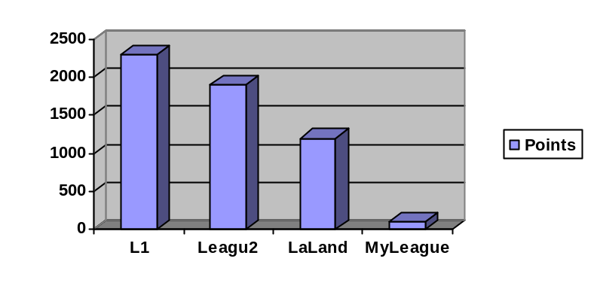
OR
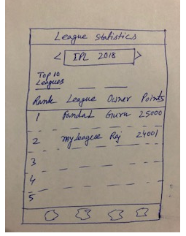
API: http://ec2-52-207-99-56.compute-1.amazonaws.com/FantasyCricketRest/api/fantasycricket/league-stats-global-top-leagues

User Stat page will consist of 2 different graphs:

- My Top Ten players in terms of Total Points. If we are showing in tabular format, we need to display column(Rank, Name, Team, Points)
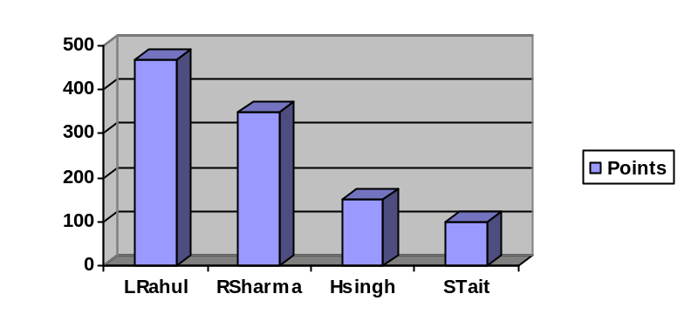
OR

API: http://ec2-52-207-99-56.compute-1.amazonaws.com/FantasyCricketRest/api/fantasycricket/user-stats-user-top-players

- Recent Match Captain Usage for last 10 matches. If we are showing as tabular format we need to show column as (Match#, Match, Captain, Points)
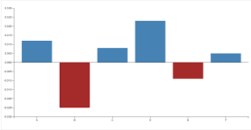
Each bar will indicate your Captain name and their points. Red bar(down) indicates negative points.

OR
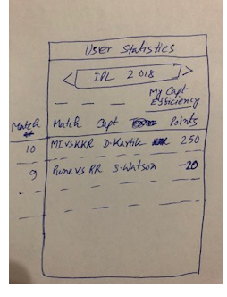

API: http://ec2-52-207-99-56.compute-1.amazonaws.com/FantasyCricketRest/api/fantasycricket/user-stats-captain-points

League Stat Page will consist 2 graphs,

- Teams’ Top Performer - In a given league top 5 teams top performing 3 players(for points) in each team,
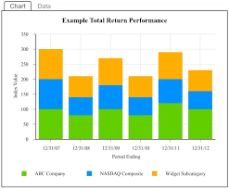
Each bar will indicate Each Team. And for each team, 3 different color means 3 different players point.

OR
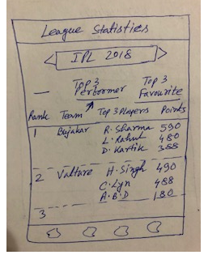
API: http://ec2-52-207-99-56.compute-1.amazonaws.com/FantasyCricketRest/api/fantasycricket/league-stats-top-teams-top-perform

- Teams’ Top Preferred Players - In a given league top 5 teams top 3 favorite players(how many matches you selected that players)
Each bar will indicate Each Team. And for each team, 3 different color means 3 different players selection.

OR
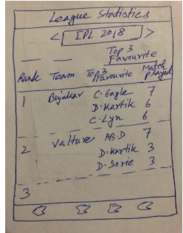

API: http://ec2-52-207-99-56.compute-1.amazonaws.com/FantasyCricketRest/api/fantasycricket/league-stats-top-teams-top-favorite

